Classifying Fake News

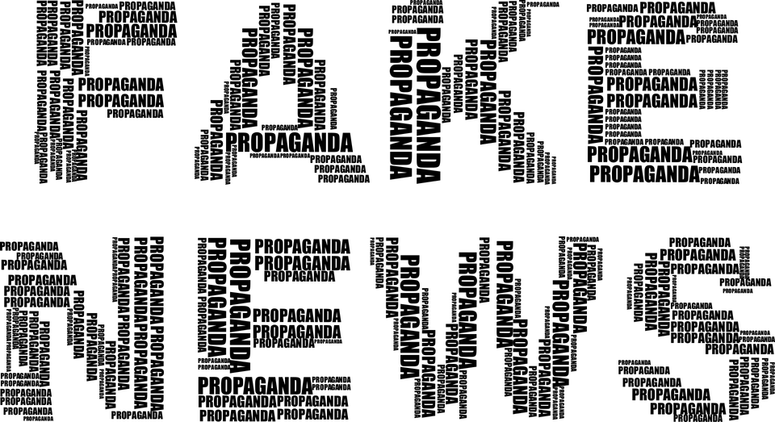

**Introduction** **3**

**Data Mining Task** **5**

**Technical Approach** **6**

**Evaluation Methodology** **7**

**Results and Discussion** **8**

**Lessons Learned** **9**

**Bibliography** **10**

**Acknowledgements** **10**

# Introduction

# 

# 

Modern society has been facing an issue consisting of hearsay, rumors and agenda led motivation. Fake news is the hot topic being discussed all over the media. It’s not just making individuals fall prey to false assumptions but makes them less likely to believe information being spread. Just a few years ago the phrase was almost never known. Despite being relatively new, the Pew Research Center has claimed “Americans rate it as a larger problem than racism, climate change, or terrorism.”

We wanted to explore the solution computer science could give to viewers worried that what they’re reading falls under the category of “fake news”.



Figure 1 : Donald Trump is believed to have made the phrase “Fake News” popular

The questions we were curious to answer were; Could data mining/machine learning predict whether a piece of news was real or fake? Which of the classifiers that we’ve learned in class would best suit this issue? The second question was relatively interesting because as computer scientists we wanted to reaffirm the “No Free Lunch Principle” and associate the best utility under our belt with the solution.

Growing up as young Americans in a very interesting time is plenty motivation. The turmoil of mainstream media being doubted constantly is always being debated. Engineering a solution would quell our own doubts of whether or not the pieces of news can be binary in regards to real or fake.

Luckily for us we are provided a data set and data mining & machine learning knowledge from our courses taken at WSU. However every situation arises certain challenges. We were dealing with a delicate issue where certain news sources are close to home for certain individuals. Thus it was important to build a classifier that had a high accuracy rate (90%+).

Our approach was to generate a machine learning model that could report back its accuracy in predicting whether the article was real or fake. We’re happy to announce that we managed to get a classifier with our confidence measure reached.

# Data Mining Task

# 

# 

The input data is a CSV file of thousands of news articles, journals and reports where they are either fake or real. Dealing with data of “fake” could be of the following nature; propaganda, biased, pseudo science, unprofessional, satire or factually inaccurate.

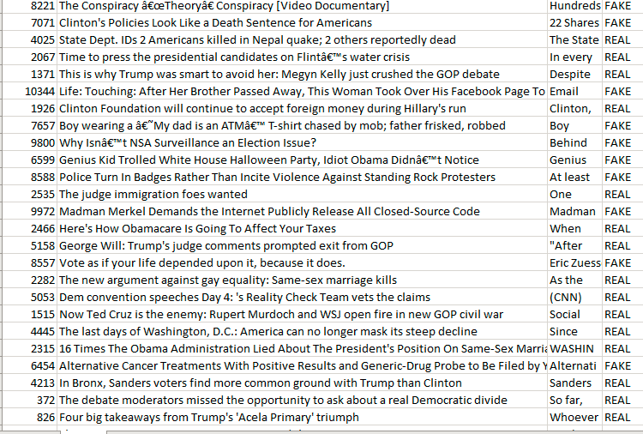  
Figure 2: Portion of data

As discussed previously our output is an accuracy rate. We want to be able to generate a classifier that is able to predict real or fake with a confidence measure of 90%. The data mining questions we want to answer is does there exist a classifier that reaches our confidence measure? The challenge is to ensure that all our previously discussed “fake news” is encompassed correctly since there are so many versions.

# Technical Approach

# 

# 

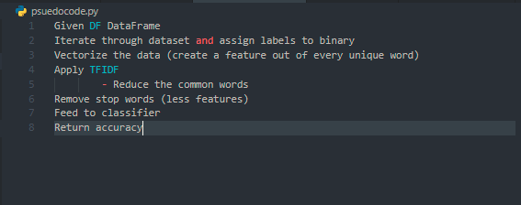

Figure 3: Pseudocode for the given program

We’ll be testing all the classifiers we’ve learned previously in our courses until we find one that can reach our confidence measure.

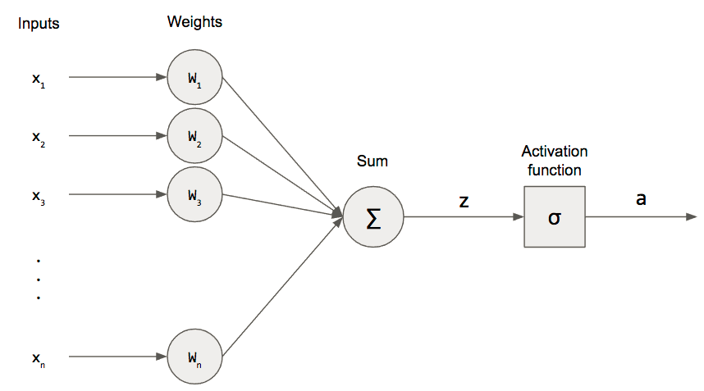  
Figure 4: Classifier we chose (ended up having best accuracy)

# Evaluation Methodology

# 

# 

Our dataset was provided by a fake news org. The goal is to use machine learning to classify news. Our only manipulation involved placing the dataset into frames and labeling them as binary.

Since confidence is the probability of the input to fall into a certain class and accuracy is the skill of the learning algorithm to predict accurately. We both understand how delicate labeling news sources as real or fake. We needed to ensure that the classifier had a high confidence rate so that without any bias it would be quite hard to doubt in regards to whether the classifier was right or wrong.

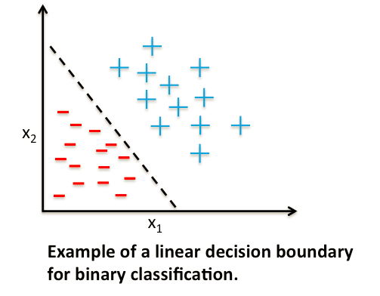  
Figure 5: Perceptron works great for linearly separable problems

# Results and Discussion

# 

# 

We chose a perceptron as our main classifier. This model managed to reach our 90% capacity as acceptable.

  
Figure 6: Accuracy of the Perceptron

The outcome of the other classifiers we tried are the following:

|  |  |
| --- | --- |
| KNN | 87% |
| Decision Tree | 77% |
| Perceptron | 92% |
| Log Regression | 90% |

What worked best was our Perceptron classifier. This is perhaps because the problem itself was binary and linearly separable. However we’re interested in seeing how the classifiers would’ve done given onsemble methods such as boosting or bagging. Creating a further question of which classifier can be best improved upon?

# Lessons Learned

# 

# 

Machine learning allows a programmer to have countless methods of approaching a problem. Using the limited knowledge that we have on techniques we’ve learned in our courses is technically enough, but not adequate enough. Researching online there are countless innovative papers involving new methods of complex programming to solve the issue of classifying news as real or fake.

We definitely overestimated data manipulation. Using pandas isn’t as simple as it seems. In order to overcome the obstacle we watched plenty of youtube videos and attended Taha’s lectures on the subject. SK learn is a beast in itself. The module is almost impossible to understand if not thanks to the great work they do with documentation.

The project definitely gave us an amazing perspective into solving real world applications. We all know that industries aren’t just creating redundant code. They’re all very interested in being a part of the cutting edge future we all have planned. Having this on our resume will definitely make us much more competitive candidates.

# Bibliography

# 

# 

1. “Debunking False Stories Archives.” *FactCheck.org*, www.factcheck.org/fake-news/.
2. “Fake News Challenge Stage 1 (FNC-I): Stance Detection.” *Fake News Challenge*, www.fakenewschallenge.org/.
3. Graham, David A. “Some Real News About Fake News.” *The Atlantic*, Atlantic Media Company, 12 June 2019, www.theatlantic.com/ideas/archive/2019/06/fake-news-republicans-democrats/591211/.
4. “Learn.” *Scikit*, scikit-learn.org/stable/.

# Acknowledgements

# 

# 

We’d like to thank Dr. Jana for teaching us the fundamentals of data mining. Dr. Diane Cook for giving us a strong foundation of beginner machine learning.